How To Backup Your ProCom Unix System Manually

First, you must be logged into your system as the user ‘root’ or a user that was previously given root privilege on your system to perform any backup procedures. If you attempt to backup files while logged in as a regular user, you may get an incomplete backup... meaning not all the files may be seen by that user.

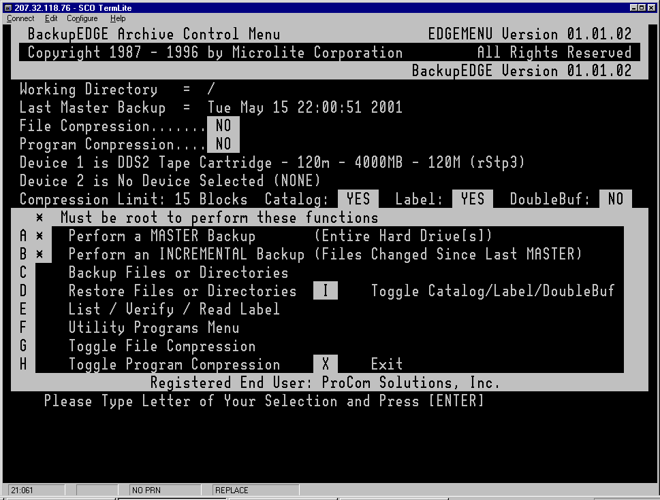
Once logged in as ‘root’, enter the command ‘edgemenu’ at the command prompt. Depending on the version of Microlite BackupEdge you have installed, you will be presented with one of the two menus you see below.
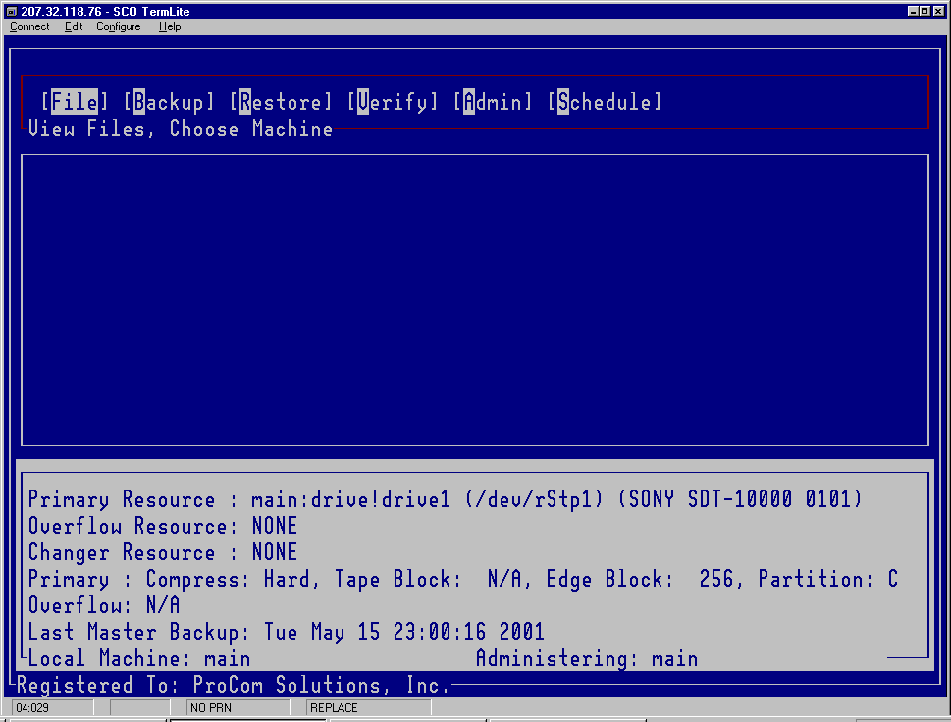
New Version Old Version

For those using the OLD VERSION:

1. Insert a tape in the tape drive.
2. Select ‘A Perform a MASTER Backup’ from the menu and press [ENTER]
3. You will be asked 3 questions about how to perform the backup. Simply accept the default answer for these three questions by pressing [ENTER] for each of them.
4. Then, the last question asks you to confirm that there is a tape in the tape drive and gives you a last chance to quit before starting the backup. If you are ready to perform this backup answer ‘Y’ and press [ENTER] otherwise answer ‘Q’ and press [ENTER].
5. After a few seconds, you should start to see it displaying a list of filenames.
6. When it is finished backing up all your files, you will be presented with a completed message and a status of the backup that includes whether the backup was successful, how long it took and the speed of the backup, etc. At this point, you can press [ENTER] to return to the beginning menu.
7. Select ‘X’ and press [ENTER] to return to the command prompt.
8. If you are finished with backing up your system, type ‘exit’ and press [ENTER] to logout.

For those using the NEW VERSION:

1. Insert a tape in the tape drive.
2. Use the arrow keys between the main keyboard and the number pad to highlight ‘Backup’ from the menu and press [ENTER].
3. A sub menu will appear below Backup. ‘MASTER BACKUP’ should already be highlighted. Just press [ENTER].
NOTE: At this point you can change options of how the backup is performed or leave them as they are. By default, this will perform a backup and then perform a verification when the backup is finished. If you wish to perform a backup without a verify change the option at the top-left corner of the screen from verify type ‘2’ to verify type ‘0’. Please do not change this option unless you speak with ProCom support.
4. ‘EXECUTE BACKUP’ should already be highlighted. You can press [ENTER] to start the backup or pres [ESC] to quit back to the main screen.
- After a few seconds you will see it displaying the filenames that it is backing up.
- When it is finished backing up all your files, you will be presented with a completed message. Press [ENTER] to continue. You will be shown the last status of the backup that includes whether the backup was successful, how long it took and the speed of the backup, etc. At this point, you can press [ENTER] to return to the beginning menu.
- With ‘FILE’ highlighted, press [ENTER] and select ‘EXIT’ from the menu and press [ENTER] to return to the command prompt.
- If you are finished with backing up your system, type ‘exit’ and press [ENTER] to logout.

